|  |  |
| --- | --- |
|  | Year 12 Specialist  TEST 5  20 Aug 2018  TIME: 50 minutes working  One page notes allowed  Classpads allowed.  43 Marks 9 Questions |

Name:_______________________________ Teacher: ____________________________

Q1 (2 & 2 = 4 marks)

Determine the general solution for the following.

1. 
2. 

Q2 (4 marks)

A hot item, initially at , is placed in a room with temperature  and left to cool, the temperature  of the item  minutes later is given by the differential equation



Determine how long it will take for the temperature of the item to cool to to the nearest second.

Q3 (2, 4 & 3 = 9 marks)

The logistical growth model is given by the following differential equation.

 where  are positive constants and 

1. State the y value where the gradient will be zero and hence give the limiting value of y.
2. Using separation of variables and partial fractions, derive the logistical formula  where  is a constant. Show all steps without the use of a classpad.

Q3 continued

1. Given that the Population  of a group of Kangaroos at  years (initially 285 kangaroos) can be modelled by the logistical growth model , determine the time taken for the population to reach 2000 kangaroos. Use your result from (b)

Q4 (4 marks)

A slope field is plotted below showing a particular line of force through point A(1,0). At point A the slope field is 6.

|  |  |
| --- | --- |
|  | Given that the slopes are horizontal at x=2 and that the lines of force are parabolic.  Determine the equation of the line of force through point A and the slope field in terms of x. |

Q5 (4 marks)

The Ant-Man is moving in a straight line so that his speed, metres per second, at displacement  metres form the origin at time  seconds can be described by the following acceleration. The Ant-Man’s speed is zero when x=1 metre from the origin.



Determine the approximate Ant-Man’s speed when metres.

Q6 (4 marks)

A particle is undergoing Simple Harmonic Motion and can be described by .

Determine what percentage of the time that the particle is **less than three quarters** of the maximum distance from the origin.

Q7 (3 & 2 = 5 marks)

An object is undergoing SHM  and is initially at rest with  units but with a positive initial acceleration.

Determine.

1. An expression for  in terms of time, .
2. The distance travelled in the first 10 seconds.

Q8 (3 & 3 =6 marks)

An object’s displacement,  metres at time,  seconds is described by 

1. Show that the motion is Simple Harmonic.
2. Determine the Amplitude and the **exact** speed when metres.

Q9 (3 marks)

The Iron Man completes a race following a unique race track so that his position vector in metres at time  seconds is given by  .metres

The motion is graphed as follows.

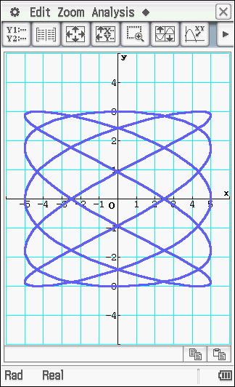

Determine the time taken to complete one circuit of the race track and the length of this cicuit.